*Imperial College of Engineering*

(RU Affiliated)

Lab Report

BSC Engineering 1st year 1st semester Examination,2024

Course title: Basic Electronics Lab

Course code: EEE 11 32

|  |  |
| --- | --- |
| **Submitted to:** | **Submitted by:** |
| **Shatu Karmokar** | **Name:Md.Rashidul Islam Zidan** |
| **Lecturer ,Department of EEE** | **Roll:23109** |
| **Imperial College of** | **Session:2023-24** |

Date: 18 /10 /2024

**INDEX**

|  |  |  |
| --- | --- | --- |
| **Lab NO** | **Content** | **Page** |
| **01** | **To study the I~V characteristics of a P-N junction diode.** | **1-6** |
| **02** | **To use PN junction diode as half-wave.** | **7-8** |
| **03** | **To study the input and output characteristics of a Transistor in CE configuration.** |  |
| **04** | **To study the characteristics of OP Amp in inverting and non inverting mode.** |  |
| **05** | **Verification of Ohm’s Law** |  |

1. **To operate different types of instrument like multimeter, oscilloscope, function generator, trainer etc.**

**Experiment No: 01**

**Name of the Experiment: To study the I~V characteristics of a P-N junction diode.**

**Objectives:**

* + **To study the V-I characteristics of the PN junction diode**
  + **Observe forward bias and reverse bias characteristics of the PN junction diode.**

**Apparatus:**

1. **Trainer Board (0-15V variable voltage supple)**
2. **Voltmeter 3. Connecting Wire Theory:**

**Do you know how the PN-Junction was invented? Click here Invention Story A semiconductor PN junction diode is a two-terminal electronic device (Di-electrode Diode.) that allows current in only one direction. The diode is formed by doping a semiconductor (like silicon or germanium) with a trivalent impurity (e.g. Boron or Aluminum) from one end to form a p-type region and with pentavalent impurity like Phosphorous from the other end to form an n-type region on the other end. The metal contacts taken out from the p-region and n-region are called anode and cathode respectively. There are three possible biasing conditions and two operating regions for the typical PN-Junction Diode, they are zero bias, forward bias, and reverse bias. When no voltage is applied across the PN junction diode then the electrons will diffuse to the P-side and holes will diffuse to the N-side through the junction and they combine. Therefore, the acceptor atom close to the P-type and donor atom near the N-side are left unutilized. An electronic field is generated by these charge**

**carriers. This opposes further diffusion of charge carriers. Thus, the movement of the region is known as the depletion region or space charge**.

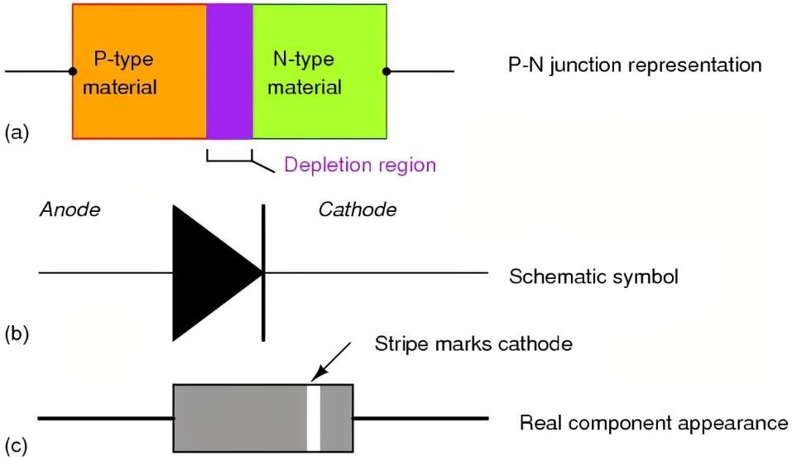

Fig-1: PN junction Diode

**Zero Biased PN Junction: Diode When a diode is connected in a Zero Bias condition, no external potential energy is applied to the PN junction. The potential barrier that now exists discourages the diffusion of any more majority carriers across the junction. However, the potential barrier helps minority carriers (few free electrons in the P-region and few holes in the N-region) to drift across the junction. Then an Equilibrium or balance will be established when the majority carriers are equal and both moving in opposite directions, so that the net result is zero current flowing in the circuit. When this occurs the junction is said to be in a state of Dynamic Equilibrium.**

**The minority carriers are constantly generated due to thermal energy so this state of equilibrium can be broken by raising the temperature of the PN junction causing an increase in the generation of minority carriers, thereby resulting in an increase in leakage current but an electric current cannot flow since nocircuit has been connected to the PN junction.**

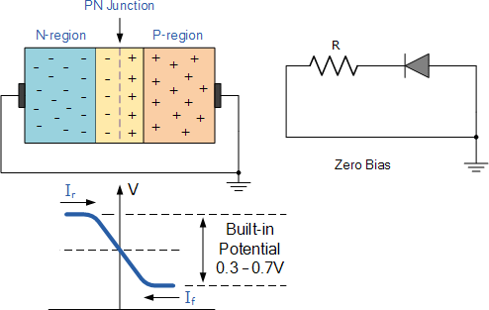

**Forward Biased PN Junction Diode: When a diode is connected in a Forward Bias condition, a negative voltage is applied to the N-type material and a positive voltage is applied to the P-type material. If this external voltage becomes greater than the value of the potential barrier, approx. 0.7 volts for silicon and 0.3 volts for germanium, the potential barriers opposition will be overcome and current will start to flow. This is because the negative voltage pushes or repels electrons towards the junction giving them the energy to cross over and combine with the holes being pushed in the opposite direction towards the junction by the positive voltage. This results in a characteristics curve of zero current flowing up to this voltage point, called the knee on the static curves and then a high current** flow through the diode with little increase in the external voltage as shown below.

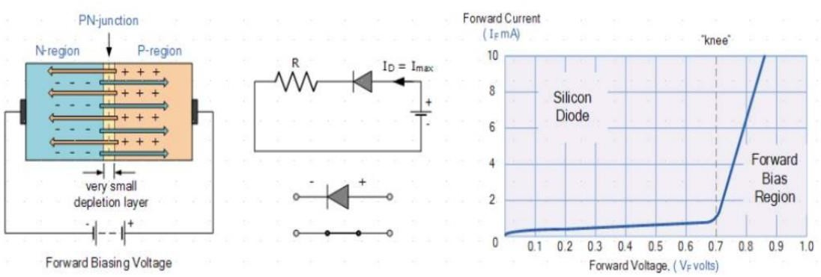

**Since the diode can conduct infinite current above this knee point as it effectively becomes a short circuit, therefore resistors are used in series with the diode to limit its current flow. Exceeding its maximum forward current specification causes the device to dissipate more power in the form of heat than it was designed for resulting in a very quick failure of the device.**

**Reverse Biased PN Junction Diode: When a diode is connected in a Reverse Bias condition, a positive voltage is applied to the N-type mate-rial and a negative voltage is applied to the P-type material. The positive voltage applied to the N-type material attracts electrons towards the positive electrode and away from the junction, while the holes in the P-type end are also attracted away from the junction towards the negative electrode. The net result is that the depletion layer grows wider due to a lack of electrons and forms a potential barrier which prevent the current from flowing through the semiconductor material.**

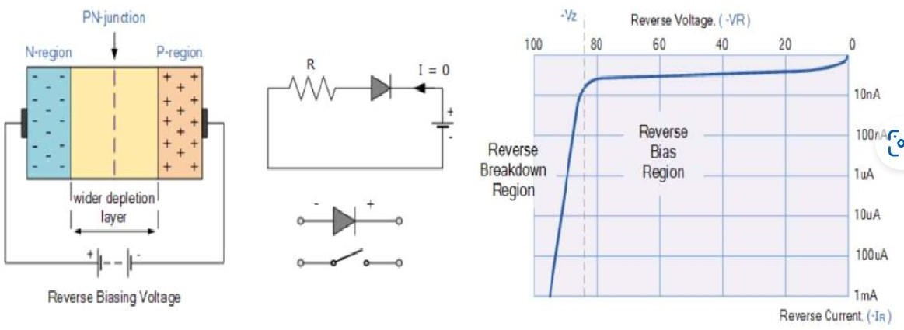

**This condition represents a high resistance value to the PN junction and practically zero current flows through the junction diode with an increase in bias voltage. However, a very small leakage current does flow through the junction which can be measured in micro-amperes. One final point, if the reverse bias voltage 𝑉𝑟 applied to the diode is increased to a sufficiently high enough value, it will cause the diodes PN junction to overheat and fail due to the avalanche effect around the junction. This may cause the diode to become shorted and will result in the flow of maximum circuit current, and this shown as a step downward slope in the reverse static characteristics curve. Sometimes this avalanche effect has practical applications in voltage stabilizing circuits where a series limiting resistor is used with the diode to limit this reverse breakdown current to a preset maximum value thereby producing a fixed voltage output across the diode. These types of diodes are commonly known as Zener Diodes and are discussed in next experiment.**

Circuit Diagram:

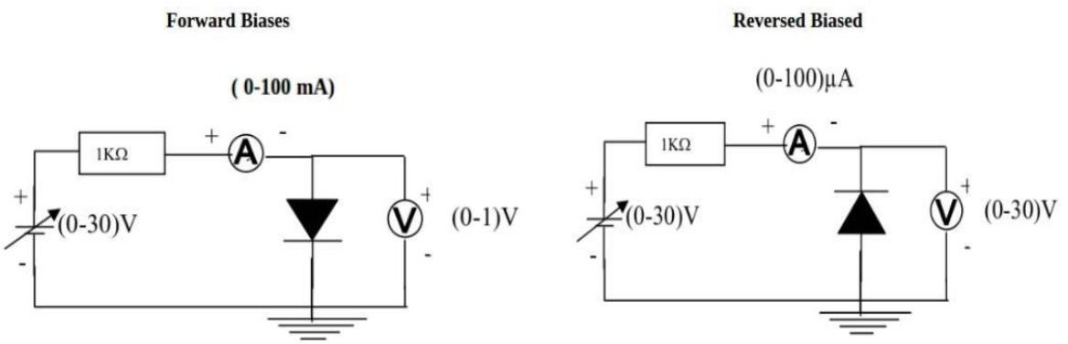

# Procedure:

**FORWARD BIAS**:

1. **Connect the circuit as per the diagram.**
2. **Vary the applied voltage V in steps of 0.1V.**
3. **Note down the corresponding Ammeter readings 𝐼𝐹.**
4. **Plot a graph between 𝑉𝐹 and 𝐼𝐹**

# REVERSE BIAS:

1. **Connect the circuit as per the diagram.**
2. **Vary the applied voltage 𝑉𝑅 in steps of 0.5V.**
3. **Note down the corresponding Ammeter readings 𝐼𝑟.**
4. **Plot a graph between 𝑉𝑅 and 𝐼𝑅**

# Observations:

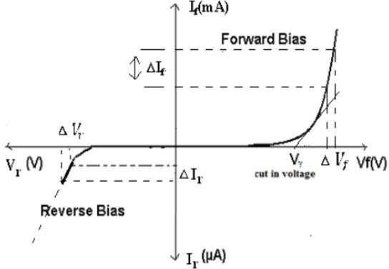

**Least count of voltmeter = V**

**Zero error of voltmeter = V**

**Range of milli-ammeter = mA**

**Least count of milli-ammeter = mA**

**Zero error of milli-ammeter = mA**

**From the graph:**

Static forward Resistance 𝑅𝐷𝐶

Dynamic forward Resistance 𝑟

= 𝑉𝑓 Ω

𝐼𝑓

= ∆V𝑓 Ω

𝑎𝑐

∆I𝑓

Static Reverse Resistance 𝑅𝐷𝐶

Dynamic Reverse Resistance 𝑟

= 𝑉𝑟 Ω

𝐼𝑟

= 𝑉𝑟 Ω

# Data Table:

𝑎𝑐

𝐼𝑟

**Forward Bias** **Reverse Bias**

|  |  |  |
| --- | --- | --- |
| SI No | Voltage (𝑉𝑓)  (in volts) | Current (𝐼𝑓)  (In mA) |
|  |  |  |
|  |  |  |
|  |  |  |
|  |  |  |
|  |  |  |
|  |  |  |

|  |  |  |
| --- | --- | --- |
| SI No | Voltage (𝑉𝑟)  (in volts) | Current (𝐼𝑟) (In mA) |
|  |  |  |
|  |  |  |
|  |  |  |
|  |  |  |
|  |  |  |
|  |  |  |

# Result and Discussion:

**Precautions and sources of error:**

1. **All connections should be neat, clean and tight.**
2. **Forward-bias voltage beyond breakdown should not be applied.**
3. **Reverse-bias voltage beyond breakdown should not be applied.**
4. **Connect voltmeter and Ammeter in correct polarities as shown in the circuit diagram.**
5. **Do not switch ON the power supply unless you have checked the circuit connections as per the circuit diagram.**

**Experiment No: 02**

**Name of The Experiment: To use PN junction diode as half-wave and full-wave rectifier**

# OBJECTIVE:

**The basic objective of this lab**

1. **To know the basic uses of diode.**
2. **To know about Half wave and full wave rectification**
3. **To know about the characteristic of half wave rectifier circuit and full wave rectifier circuit.**
4. **To design a circuit using diode and other electronic circuit.**

# Apparatus:

1. **Transformer**
2. **Trainer board**
3. **Oscilloscope**
4. **Diode**

# Theory:

The main application of p-n junction diode is in rectification circuits. These circuits are used to describe the conversion of a.c signals to d.c in power supplies. Diode rectifier gives an alternating voltage which pulsates in accordance with time.

# Working of Half Wave Rectifier

**The half-wave rectifier has both positive and negative cycles. During the positive half of the input, the current will flow from positive to negative which will generate only a positive half cycle of the a.c supply. When a.c supply is applied to the transformer, the voltage will be decreasing at the secondary winding of the diode. All the variations in the a.c supply will reduce, and we will get the pulsating d.c voltage to the load resistor.**

